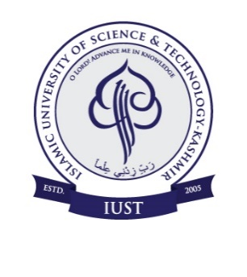
ISLAMIC UNIVERSITY OF SCIENCE & TECHNOLOGY
AWANTIPORA, KASHMIR

Walk-In-Interview

For engagement of Contractual Assistant Professors on need basis Academic Arrangement for the Spring Session-2020

Applications are invited from the eligible candidates for walk-in-interview on the prescribed format, which can be downloaded from the University website at www.islamicuniversity.edu.in for engagement of contractual Assistant Professors on need basis academic arrangement for the Spring Session-2020 in the following disciplines.

S.No. | Department | Eligibility | Interview Date
 | Journalism & Mass Communication | Master‘s degree with 55% marks in the concerned/relevant subject from an Indian University, or an equivalent degree from an accredited foreign University with NET/SET/Ph.D. | 02-03-2020
 | Computer Science | MCA/M.Sc. IT with 55% marks with NET/SET/Ph.D.

Interested candidates should report to the office of the concerned Dean School of Study, Islamic University of Science & Technology, Awantipora along with all relevant documents in original and a set of xerox copies (self attested) on the dates shown against each at 10.00 a.m. positively:

Note(s):

- The engagements are purely on need basis for Spring Session-2020 (ending 31-07-2020) or till the posts are filled on substantive basis, whichever is earlier.
- No TA/DA shall be paid to candidates for appearing in the interview.
- Candidates should report at the venue 1hr before the scheduled time for scrutiny of documents.

Sd/-
Registrar
No. IUST/Reg/Adv/20/E/252
Dated: 26-02-2020.

