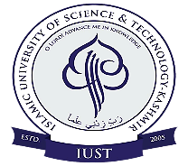**Department of Environment Sustainability and Climate Change**

ISLAMIC UNIVERSITY OF SCIENCE & TECHNOLOGY (IUST),

AWANTIPORA-192122, KASHMIR

**Dr. Sumira Nazir Zaz**

Coordinator

Email: zaz.sumira@gmail.com

Dated: 07-01-2020

**No.** IUST/DESCC/RS/1/04/15

**Dated:** 04th September, 2024

March, 2024

Dated: 07-01-2020

This is to inform to all the faculty members that a Departmental Committee (DC) meeting has been scheduled for **06 September, 2024 at 11.00 AM** to review and discuss the progress of Ph.D. syllabus development. Your insights and feedback are crucial to ensure that our syllabus aligns with academic standards and addresses the needs of students.

Please make it convenient to attend the meeting.

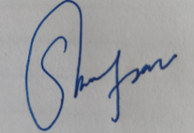

Coordinator