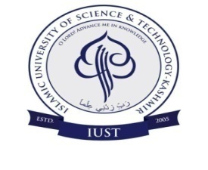
Department of Electrical Engineering
Date sheet for Mid Term Examination of B-Tech 1st semester and Elective Courses Department of Electrical Engineering.

Semester | Day/Date | Course Title. | Timing
Ist | 28-11-2017 (Tuesday) | Physics-I (PHY-111)T | 1st Meeting  10:15-11:45 am
 | 29-11-2017 (Wednesday) | Environmental Science (BIO-101T)
 | 30-11-2017 (Thursday) | Mathematics-I (MTH-111T)
 | 04-12-201 (Monday) | Basic Electrical Eng. (ELE-101T)
 | 06-12-2017 (Wednesday) | Chemistry-I (CHM-111T)
 | 07-12-2017 (Thursday) | Engineering Drawing(CIV-105T/P)
3rd/5th | 07-12-2017 (Thursday) | Electives  Introduction to Electrical Technology(ELE-G02T)  Renewable Energy Sources (ELE-E04T) | 10-15-11-45 am

Mr. Zahoor Ahmad
Coordinator Examination
Department of EE
Dr. S. A. Nahvi
I/C Head
Department of EE

Copy to:
- D.A.A
- I/C Controller Examination
- DR Academics
- Head, Department of CE/ECE/ME/Physics/Chemistry/CSE/Maths

